Study of Pedestrian and Slow-moving Traffic Control Behaviour at Congested Intersections for Urban Areas in Educational and Recreational Zones to Achieve SDGs-2030 Targets

Abstract: In developing countries like India, Chandigarh city of urban planners, traffic engineers, and policymakers must consider a range of factors that can impact pedestrian behaviour and safety. These factors include population density, the presence of public transportation, and the nature and frequency of activities occurring in specific areas. The study's objective is to enhance pedestrian safety useful to carefully evaluate these unique characteristics when designing and implementing strategies for congested intersections in urban areas. By adopting a comprehensive approach, we can create more sustainable and liveable urban environments, Sustainable Development Goal –11, that prioritize the well-being and safety of all residents and visitors in city communities. The present study employs a comprehensive methodology that entails an extensive observational analysis and data collection at intersections located within congested zones. By examining various factors that influence pedestrian behaviour, such as traffic flow, pedestrian density, and traffic signals, the research aims to generate valuable insights into the intricacies of navigating diverse urban landscapes. The findings of this study can aid city planners and policymakers in making informed decisions regarding the design of safer and more efficient pedestrian infrastructure. The study's findings underscore the significance of accounting for the unique characteristics of diverse urban areas in the design of pedestrian-friendly intersections. Through an analysis of both quantitative and qualitative aspects of pedestrian behaviour, the research offers a detailed and nuanced comprehension of the intricate dynamics involved. This understanding is particularly valuable in informing effective urban planning strategies that prioritize the safety and convenience of pedestrians. This study underscores the significance of effectively employing context-specific interventions to address pedestrian behaviour. By acknowledging the distinctive challenges posed by different areas, urban planners can design targeted measures to enhance pedestrian safety and optimize traffic flow in congested zones. This approach has the potential to achieve better outcomes in terms of safety and mobility for all pedestrians.
Keywords: Pedestrian, effective walkway, urban planning, flow rate, walkway width

1. General

1.1 Scope of Study
Traffic accidents involving pedestrians have become a major global safety concern, especially in developing countries with high population density, rapid urbanization, and non-compliance with traffic rules by both drivers and pedestrians [2]. Pedestrian crossings, which are meant to provide safety, have become a common site of accidents, either when drivers neglect traffic rules or when pedestrians try to force their way through the traffic stream. Additionally, high foot traffic at pedestrian crossings can cause unacceptable delays for vehicles. Pedestrians are a significant contributor to urban traffic accidents, and the need for targeted interventions and urban planning strategies to enhance pedestrian safety is urgent [1]. Our research on pedestrian behaviour is critical in developing holistic strategies that address the multifaceted challenges associated with pedestrian safety in India's diverse urban landscape. By merging the insights from the pedestrian accident study, we can contribute to making pedestrian crossings safer and reducing the number of accidents in India and other developing countries to achieve Sustainable Development Goal 11, 2030 [9].

1.2 Traffic in India
The release of a comprehensive study on pedestrian accidents in India during the 7th UN Global Road Safety Week sheds light on this critical issue. The study, which analysed 6,300 accidents through the Road Accident Sampling System for India (RASSI), revealed that pedestrian accidents account for nearly 10% of traffic fatalities in the country. This alarming statistic underscores the need for targeted interventions and urban planning strategies to enhance pedestrian safety in diverse urban settings. The study also found that rural roads pose a heightened risk to pedestrians, accounting for 56% of all pedestrian accidents. This finding reinforces the importance of our research, which explores pedestrian dynamics in various zones and aligns with the report's identification of challenges in rural, urban, and semi-urban environments. Contrary to common belief, the study challenges the notion that most accidents occur at night, with 57% of pedestrian accidents happening during the day. This resonates with our exploration of pedestrian behaviour throughout different times, providing a more nuanced understanding of risk factors. The study also highlights that human error is the primary cause of pedestrian accidents, emphasizing the significance of behavioural factors in shaping pedestrian movement. Additionally, the study's unique observation of pedestrians stopping in the middle of the road to let vehicles pass adds a valuable cultural dimension. This underscores the need for culturally sensitive interventions in urban planning that consider local practices and habits.

1.3 Traffic in Chandigarh
As a city, Chandigarh has emerged as a remarkable success story by providing its inhabitants with a high standard of living, accompanied by substantial growth. This has made it an attractive destination for not only middle and upper-class families but also skilled and unskilled workers. According to estimates, the city's urban population in 2011 was 10.55 lakh, with the villages surrounding the city growing even faster. With the rapid growth of satellite towns, coupled with the increase in living standards as shown in Table 1.
Table 1. Data on Pedestrian and Cyclist Accidents in Chandigarh [8].

Road Crashes Data -2018-2023
Year | Total Cases | Fatal Cases | Killed Persons |  | Pedestrian Deaths |  | Cyclist Deaths |  | Two- Wheeler Deaths |  | Non-Fatal Cases | Injured Persons |  | U/s 174
 |  |  |  |  |  |  |  |  |  |  |  |  |  | CrPC
2018 | 316 | 97 | 98 |  | 35 |  | 11 |  | 40 |  | 219 | 300 |  | 21
 |  |  | M | F | M | F | M | F | M | F |  | M | F
 |  |  | 83 | 15 | 27 | 8 | 10 | 1 | 35 | 5 |  | 232 | 68
2019 | 305 | 100 | 104 |  | 36 |  | 10 |  | 46 |  | 205 | 275 |  | 29
 |  |  | M | F | M | F | M | F | M | F
 |  |  | 84 | 20 | 25 | 11 | 8 | 2 | 41 | 5 |  | 216 | 59
2020 | 159 | 50 | 53 |  | 12 |  | 10 |  | 20 |  | 109 | 148 |  | 9
 |  |  | M | F | M | F | M | F | M | F |  | M | F
 |  |  | 46 | 7 | 9 | 3 | 10 | 0 | 20 | 0 |  | 117 | 31
2021 | 208 | 94 | 96 |  | 24 |  | 17 |  | 32 |  | 114 | 172 |  | 14
 |  |  | M | F | M | F | M | F | M | F |  | M | F
 |  |  | 79 | 17 | 18 | 6 | 15 | 2 | 29 | 3 |  | 135 | 37
2022 | 237 | 79 | 83 |  | 23 |  | 12 |  | 40 |  | 158 | 203 |  | 21
 |  |  | M | F | M | F | M | F | M | F |  | M | F
 |  |  | 68 | 15 | 16 | 7 | 12 | 0 | 35 | 5 |  | 164 | 39
2023 upto 27.05.2023 | 68 | 24 | 27 |  | 8 |  | 6 |  | 9 |  | 44 | 67 |  | 8
 |  |  | M | F | M | F | M | F | M | F |  | M | F
 |  |  | 21 | 6 | 5 | 3 | 5 | 1 | 7 | 2 |  | 53 | 14
*CrPC: Code of Criminal Procedure is the main legislation on procedure for the administration of substantive criminal law in India.
There has been an unprecedented surge in motor vehicle ownership in recent years, resulting in a substantial increase in the number of vehicular trips made. The number of cars on the city's roads is increasing daily, leading to a steep rise in traffic. Nonetheless, the city's street system has some glaring defects, including insufficient junction spacing and arbitrary treatment at significant intersections. As per available data, as many as 19.71% of fatal accidents in Chandigarh involve cyclists. Additionally, the variation of speed for different categories of traffic exacerbates the severity of accidents and the number of conflicts with pedestrians.

1.4 Design for Pedestrian Facilities
To ensure the safety of pedestrians, it is essential to provide separate footpaths next to the carriageway on urban streets. These footpaths should be located on both sides of the road, and ideally, they should be raised above the street level. To encourage people to use the footpaths, they should be well-paved and maintained properly [11]. They should also be sloped appropriately to allow rainwater to drain away. A crossfall within the range of 1 in 40 is considered sufficient. For the safety of pedestrians, separate footways should be provided alongside the carriageway of urban streets. They should be provided on either side of the road and should preferably be raised above the general carriageway level. To attract full-use pedestrians, they should be properly surfaced or paved. They should be sloped adequately to drain away the rainwater as shown in Table 2, Table 3 and Figure 1.

Table 2. Recommended Minimum Footway Width as per U.K. standards. [3]

Type of road | Recommended minimum footway width
Primary Distributor
Urban Motorway | No footway
All-purpose road | 2.7m
District distributor | 2.7 m in principal business and industrial districts
Local distributor | 2.4 in residential districts.
 | 2.7 m in principal business and industrial districts
Access road | 1.8 m in residential districts
 | The principal mean of access: is 2.7 m in principal business districts
 | 1.8 m in industrial districts
 | 1.8 m normally in residential districts
 | 3.7-4.5 m adjoining shopping frontage.
 | The secondary mean of access: 0.9 m verge instead of footway on road in principal business and industrial districts.
 | 0.6 m verge instead of footway on road in residential districts

Table 3. Recommended Minimum Footway Width as per I.R.C guidelines [4].

Width of Footpath (m) | Capacity in number of people per hour
 | All in one direction | In both direction
1.5 | 1,200 | 800
2 | 2,400 | 1,600
2.5 | 3,600 | 2,400
3 | 4,800 | 3,200
4 | 6,000 | 4,000

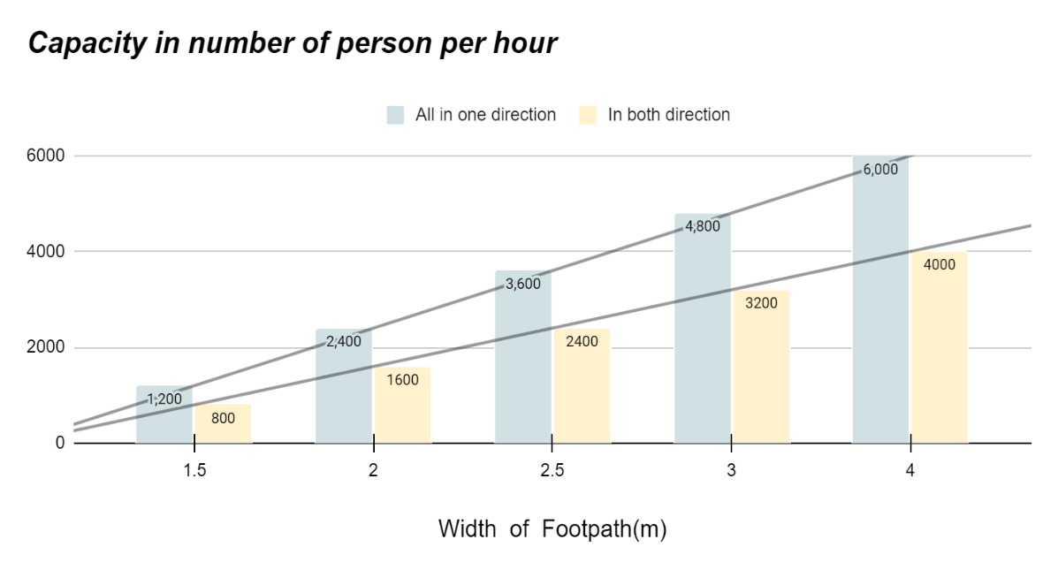
Fig 1. Footpath Capacity Based on Width (meters) - Maximum Pedestrian Throughput in One and Both Directions per Hour

1.5 Highway Capacity Manual Methodology
The proposed methodology presents a comprehensive framework for the critical evaluation of pedestrian facilities. Using this framework, analysts are empowered to investigate the impact of bicycles and traffic signals on pedestrian facilities and the effect of pedestrian volume on flow and level of service (LOS) [6].

1.6 Pedestrian LOS
HCM analyses pedestrian LOS based on pedestrian flow rate and sidewalk space. As density increases, pedestrian speed decreases, and mobility declines. Pedestrian LOS is calculated using pedestrians per minute per meter (ped/min/m). Effective sidewalk width is calculated by subtracting obstacle widths and a 0.30 to 0.45 m buffer width per obstacle from the total width. Using the pedestrian unit flow rate, pedestrian LOS can be calculated using the “Average Flow LOS Criteria for Walkways and Sidewalks.” The platoon LOS table can be used to obtain the platoon LOS. HCM states that platoon LOS is generally one level poorer than that determined by average flow criteria.
1.7 Uninterrupted-Flow Pedestrian Facilities
Pedestrian facilities that are continuous and uninterrupted include both separate and shared pedestrian paths, both indoors and outdoors, that are designated for pedestrian use. These pedestrian facilities are unique because pedestrians do not experience any disruption, except for interaction with other pedestrians, and, on shared paths, with other non-motorized modes of transportation. These procedures should consider pedestrian walking speed, pedestrian start-up time, and pedestrian space requirements to ensure efficient pedestrian flow [5].
1.8 Walkways and Sidewalks
Pedestrian walkways and sidewalks are designed to keep pedestrians safe by separating them from motor vehicle traffic. Bicycles or any other type of user, besides pedestrians, are not allowed on these paths. Such facilities are commonly built on city streets, airports, subways, and bus terminals. These pedestrian facilities include straight sections of sidewalk, terminals, stairs, and crosswalks where streams of pedestrians cross as depicted in Table 4.

Table 4. Criteria for determining the average flow LOS of walkways and sidewalks.

LOS | SPACE(M/p) | FLOW RATE(P/MIN/M) | SPEED(M/S) | V/C RATIO
A | >5.6 | <=16 | >1.30 | <=0.21
B | >3.7-5.6 | >16-23 | >1.27-1.30 | >0.21-0.31
C | >2.2-3.7 | >23-33 | >1.22-1.27 | >0.31-0.44
D | >1.4-2.2 | >33-49 | >1.14-1.22 | >0.44-0.65
E | >0.75-1.4 | >49-75 | >0.75-1.14 | >0.65-1.0
F | <=0.75 | Variable | <=0.75 | Variable

1.9 Determining Pedestrian Walking Unit Flow Rate
To make field observations simpler, the pedestrian unit flow rate is used to measure service. To calculate the pedestrian unit flow rate, the peak 15-minute count and the effective walkway width must be determined. The formula for calculating pedestrian unit flow rate is v_{p} = v₁₅ x W_{e} x 15, where v_{p} is the pedestrian unit flow rate (p/min/m), v₁₅ is the peak minute flow rate (p/15-min), and W_{e} are the effective walkway width (m).
v_{p} = v₁₅ / 15 * W_{e}
where v_{p} = pedestrian unit flow rate (p/min/m),
v₁₅ = peak 15-min flow rate (p/15-min), and W_{e} = effective walkway width (m).

1.10 Determining Pedestrian Walking Space
When it comes to evaluating walkways and sidewalks, the most important factor to consider is space, which is the opposite of density. Space can be measured on-site by calculating the facility's sample area and determining the number of pedestrians that can occupy that area at any given time.
Space = 1 / Density

1.11 Determining Pedestrian Walking Speed
The speed at which pedestrians walk can be affected by the percentage of elderly pedestrians (aged 65 or above) in the walking population. For walkway computations, a walking speed of 1.2 m/s is recommended if 0 to 20 per cent of pedestrians are elderly. However, if the proportion of elderly pedestrians exceeds 20 per cent, a walking speed of 1.0 m/s is recommended. Furthermore, any increase of 10 per cent or more in the number of elderly pedestrians can cause a decrease in walking speed of 0.1 m/s.

1.12 Determining Effective Walkway Width
Calculating the effective walkway width is important as it refers to the portion of the walkway that is usable by pedestrians. Various obstructions can make pedestrians avoid certain areas of the walkway. These obstructions can be found in Figure 1. The effective walkway width can be calculated using the equation below:
W_{E} = W_{T} – W_{O}
Where W_{E} = effective walkway width (m),
W_{T} = total walkway width (m),
W_{O} = sum of widths and shy distances from obstructions on the walkway (m).
Figure 2 provides a schematic showing common obstacles and the estimated width of the walkway. The values in Figure 1 can be used in cases where specific walkway configurations are not available.
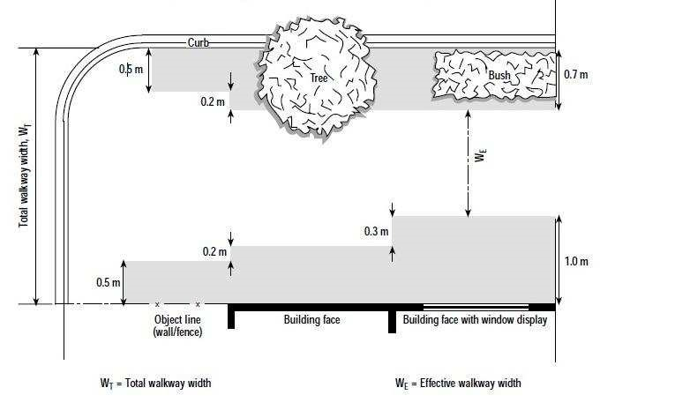
Fig 2. Determination of effective walking width [7]
To evaluate the effect of occasional obstructions, such as trees or poles, it is customary to assume that their effective length is five times their effective width. To determine the average impact of these obstructions, one can multiply their effective width by the ratio of their effective length to the average distance between them. Furthermore, it is imperative to consider the presence of right-turning vehicles while pedestrians cross a signalized intersection. These vehicles may occupy a portion of the crosswalk during the crossing phase, rendering it unusable for pedestrians. In such cases, the effective crosswalk width can be determined by subtracting the appropriate time space used by the right-turning vehicles [10].

1.13 Madhya Marg Detail Study
Recreational Zones
The data was collected on the intersection present near PGIMER, Chandigarh connecting Sector – 11, 12, 14, and 15 during the peak hour. The number of cyclists and other NMT modes has been counted separately on the cycle tracks and the main road. The footpath in front of Nehru Hospital (NH) Block PGIMER is covered with food and accessories stalls. The garbage generated is not maintained well. The conditions accurately depict the location and its current condition as shown in Figure 3 and Figure 4 [12].

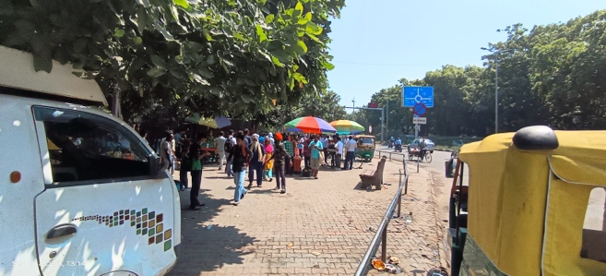
Figure 3. Intersection at PGIMER, Chandigarh - Depicting current conditions of footpaths with food and accessory stalls and inadequate garbage maintenance in front of Nehru Hospital (NH) Block

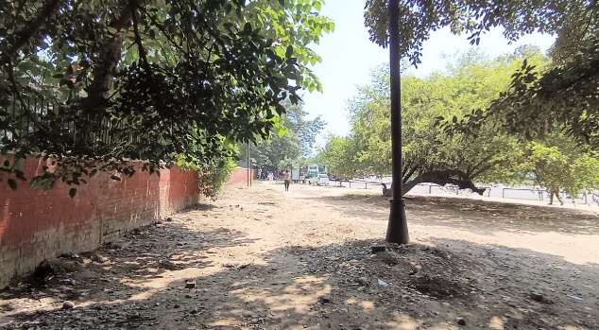
Figure 4. The intersection at Sector-11,12,14 and 15, Chandigarh - Depicting current conditions of non-availability of cycle tracks in front of PGI bus stand, Chandigarh

Table 5. Data of pedestrian count and LOS

Time  interval | No. of  Pedestrian | Flow rate  (Ped/min/m) | Space  (m2/  Ped) | Level of service
1:00-1:15 | 54 | 0.108 | 55.55 | A
1:15-1:30 | 51 | 0.102 | 58.82 | A
1:30-1:45 | 55 | 0.011 | 545.4 | A
1:45-2:00 | 57 | 0.0114 | 526.3 | A

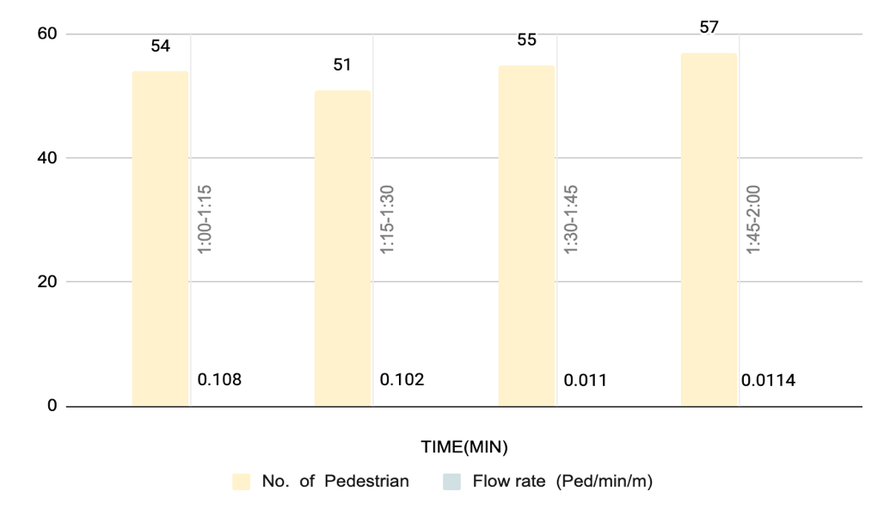
Fig 5. Pedestrian Flow Analysis Over Time Intervals - Pedestrian Count, Flow Rate in Recreational Zones

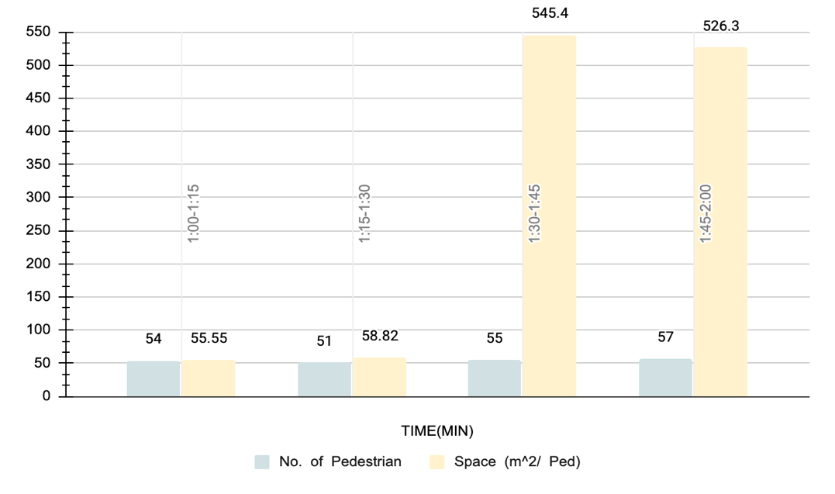
Fig 6. Pedestrian Flow Analysis Over Time Intervals - Space per Pedestrian, and Level of Service in Recreational Zones

Educational Zone
The intersection is located in front of Punjab Engineering College on Vidya Path, near the bus stop. The number of cyclists and other NMTs has been counted separately on the intersection, cycle track, and main road of Vidya Path. The footpath and cycle tracks are not well maintained. The dimensions of the 100m section and the photograph accurately represent the location and its current condition as shown in Figure 7 [7].

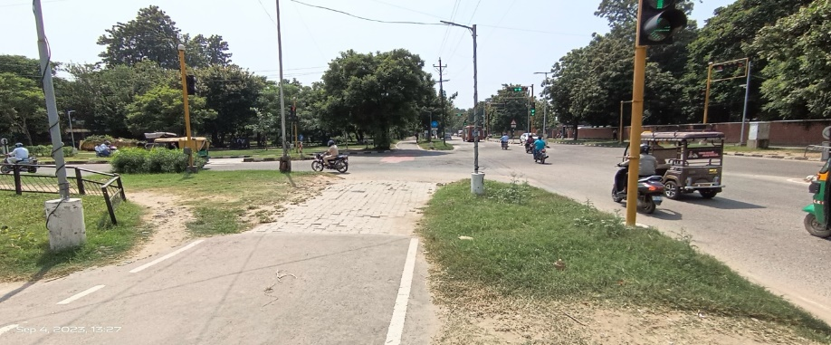
Figure 7. Intersection at Vidya Path near Punjab Engineering College - Depicting the current condition of the location for the counting of cyclists and other Non-Motorized Transport (NMT) users

Table 6. Data of pedestrian count and LOS

Time  interval | No. of  Pedestrian | Flow rate  (Ped/min/m) | Space  (m2/  Ped) | Level of service
1:00-1:15 | 117 | 0.0234 | 256.4 | A
1:15-1:30 | 125 | 0.025 | 240 | A
1:30-1:45 | 127 | 0.0254 | 236.2 | A
1:45-2:00 | 121 | 0.0242 | 247.9 | A

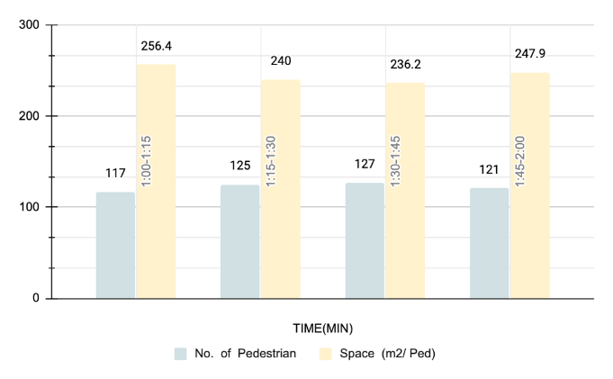
Fig 8. Pedestrian Flow Analysis Over Time Intervals - Pedestrian Count, Flow Rate in Educational Zones
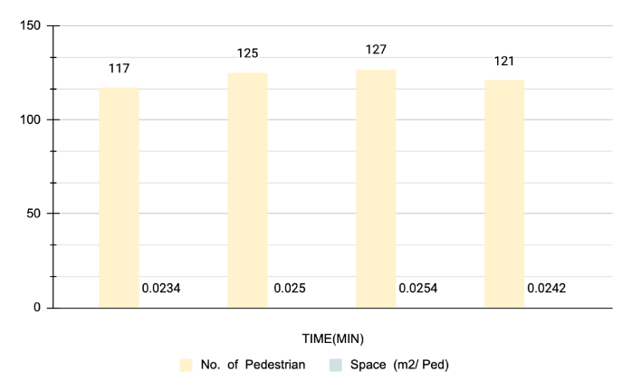
Fig 9. Pedestrian Flow Analysis Over Time Intervals - Space per Pedestrian, and Level of Service in Educational Zones

Conclusion
The study conducted on pedestrian and slow traffic behaviour at intersections in densely populated areas within educational and recreational districts is a comprehensive report that reveals the importance of multiple factors that must be considered to ensure the safety and effectiveness of these areas. The study was conducted in India, with a particular emphasis on Chandigarh, to understand the challenges and complexities of managing pedestrian movement in urban environments across the country. Through this study, several crucial points have been identified that require attention to improve the safety and well-being of pedestrians. Firstly, the study highlights the alarming statistics related to pedestrian accidents, particularly in densely populated urban areas such as India. Immediate attention and focused responses are needed to improve pedestrian safety. The study suggests that the number of pedestrian accidents can be reduced by implementing measures such as speed limits, pedestrian crossings, and traffic calming devices. Secondly, the study emphasizes the importance of behavioural factors in ensuring safety and highlights the cultural dimensions of pedestrian interactions with traffic that are crucial for effective urban planning. The study suggests that a better understanding of the cultural nuances of the local population is required to create an effective urban planning strategy that prioritizes pedestrian safety. Thirdly, the study identifies context-specific interventions as essential and noteworthy. Recognition and acknowledgement of the significance of local practices and habits are required to create a safer and more habitable urban environment. The study suggests that local authorities should work with the community to identify potential hazards and implement strategies that are tailored to the needs of the local population. Fourthly, the study emphasizes the importance of better traffic management, particularly at busy intersections. Collected and analyzed data highlights the need to assess traffic flow, pedestrian density, and signalization for optimized traffic flows and increased safety for pedestrians. The study suggests that a better understanding of traffic patterns and pedestrian behaviour is required to create an effective traffic management strategy that prioritizes pedestrian safety. This study highlights the need for a comprehensive and context-dependent approach to improving pedestrian safety in densely populated areas within educational and recreational settings. It involves the establishment of infrastructure, enhancements in traffic management, and behavioural changes that prioritize pedestrian safety and well-being. Ultimately, this approach has the potential to create safer, more efficient, and more habitable urban environments for all residents and visitors.

Availability Data and Materials

All data, models, and code generated or used during the study appear in the submitted article. All the data used and provided in this research have already been presented in this article.

Conflict of Interest
Not applicable, the authors proclaimed that no potential conflicting situations regarding the examination, origin, as well as production of this article.

Funding
The author got budgetary, help for the explorations, as well as making of this article with the help of the Department of Science and Technology and Renewable Energy, Chandigarh Administration.

Author’s contributions
The author(s) checked and accepted the final manuscript.

References
- Guo, H., Wang, W., Guo, W., Jiang, X. and Bubb, H., 2012. Reliability analysis of pedestrian safety crossing in urban traffic environment. Safety Science, 50(4), pp.968-973.
- Adinarayana, B., 2022. Modeling of Pedestrians Travelling Behaviour (PTB) on Urban Environment for COVID-19 Pandemic using MLR Algorithm Analysis. International Journal of Performability Engineering, 18(3), p.213.
- Department of Environment (U.K). (1966). Road in Urban Area. London: H.M.S.O.
- Indian Roads Congress. (1989). Guideline for Pedestrian Facilities, I.R.C:103-1988. New Delhi.
- Adinarayana, B. and Mir, M.S., 2021. Development of pedestrian safety index models for safety of pedestrian flow at un-signalized junctions on urban roads under mixed traffic conditions using MLR. Innovative Infrastructure Solutions, 6, pp.1-9.
- Transportation Research Board. (2000). Highway Capacity Manual, HCM-2000. Washington DC.
- Singh, R.R. and Singh, E.G., 2014. Study on Pedestrian and slow-moving traffic. International Journal of Research in Engineering and Technology ISSN, pp.2319-1163.
- https://trafficinfratech.com/chandigarh-on-going-fight-against-serious-road-accidents
- Tonne, C., Adair, L., Adlakha, D., Anguelovski, I., Belesova, K., Berger, M., Brelsford, C., Dadvand, P., Dimitrova, A., Giles-Corti, B. and Heinz, A., 2021. Defining pathways to healthy sustainable urban development. Environment international, 146, p.106236.
- Adinarayana, B. and Mir, M.S., 2017, December. A review paper: study on safety of side walkability facilities in urban areas of developing countries. In ASCE India Conference 2017 (pp. 590-597). Reston, VA: American Society of Civil Engineers.
- Dixit, A. and Dixit, P., EXAMINE THE EFFECT OF TRAFFIC CONGESTION IN A SMART CITY. A CASE OF SAGAR (MP) INDIA.
- Adinarayana, B. and Mir, M.S., 2018. Study of Pedestrian Safety on Urban Roads under Mixed Traffic Conditions. International Journal of Engineering Science, Advanced Computing and Bio-Technology, 9(4), pp.120-137.

